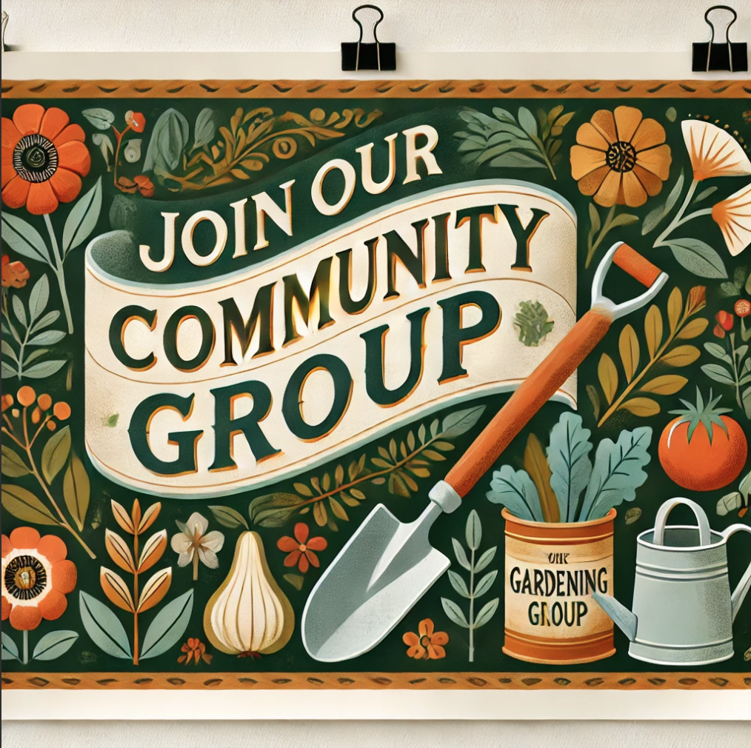

**We’re looking for friendly and enthusiastic volunteers to help create**

**a local community garden next door to the surgery!**

This is a fantastic opportunity to:

* Get outside and enjoy some fresh air
* Grow your own vegetables, fruits, and flowers
* Meet new people and share a cup of tea
* Be part of something that makes a real difference in our community

No experience necessary—just a love for the outdoors and a willingness to get involved! Whether you’re an experienced gardener or a complete beginner, everyone is welcome.

This group is all about coming together, learning from one another, and improving our well-being through gardening, good company, and a bit of fresh air.

If you’d like to get involved or find out more, please call the Allotment Officer on: 0748 335 0168.

**Let’s grow something great together!**